*Cedar Cliff H. S.*

*December 2024 Update*

Happy Holidays, Class of 1961

However you are celebrating this year, we hope that you have a blessed and joyful time with your family and friends. If you are like Lori and I you may have cut back on decorations and preparation, but as long as you gather with family and friends and celebrate the birth of our Savior, you will certainly be blessed. May we all keep Christmas in our hearts and have a happy, hopeful and healthy New Year.

Thanks to all of you who have contributed your thoughts, memories, pictures and suggestions this past year. We are fortunate to have a very special sharing this year by Ellen Coleman Andes for our Christmas Update. Ellen and her husband Gene (1960) have moved from New Orleans to New Mexico and like many of us are now closer to family.

Ellen is/ was very talented and many of you will remember her as the harpist in Cedar Cliff Stage Band Obviously she has many hidden talents which she shares with us here.

For years, Fall meant it was time to start making Christmas gifts for everyone–hats or scarves, occasionally a sweater, for the guys; hats or shawls for the girls (at last count one of my daughters-in-law told me I had gifted her seven shawls). These items were either knit or handwoven.

Handknit shawls
Handwoven scarves and handknit socks
Handknit scarves


Then In 2002 when I was a librarian at Richard Bland College in Petersburg, Virginia, I became a member of the Southside Virginia Chapter of the American Needlepoint Guild. After that I pretty much switched over to making stitched items. Last year I made ornaments for everyone but forgot to take photos. Here are some photos of items (other than handknits or hand wovens) we’ve gifted recently.

Handwoven Christmas decorations
Stitched candy bowl
Needlepoint Apple


I’m very fortunate to have a husband who also likes working with his hands. We’ve raised sheep, run a knitting and weaving shop, written books on macrame and weaving (Gene writing, me doing some knotting and weaving). Gene also builds ship models from scratch (see photos at [eeandes.com](http://www.eeandes.com/)) and is experimenting with fine art printing. If you are interested in reading about our travels and other endeavors go to [eeandes.com](http://eeandes.com). To all of you: Have a Wonderful Holiday! Ellen

Pop Culture- A Christmas Quiz

Our favorite- multiple guess

1. On what early December Day, does the mythical St. Nikolaus appear? A, December 1st, the first Sunday in Advent; B-December 6, his traditional Birthday; C- December 21, the Winter Solstice.
2. How many candles are typically on the Advent Wreath? A- two; B-four; C- five:
3. What does Rudolf’s elf companion really want to be? A-an architect; B- a dentist; C- a circus entertainer.
4. When does the Christmas season officially end? A- Christmas Day of course; B- January 1st, the beginning of the New Year; C- The 6th of January, known as Epiphany.
5. Who narrates the Christmas Song “Frosty the Snowman? A- Jimmy Durante; B- Bobby Darrin; C- Mickey Rooney.

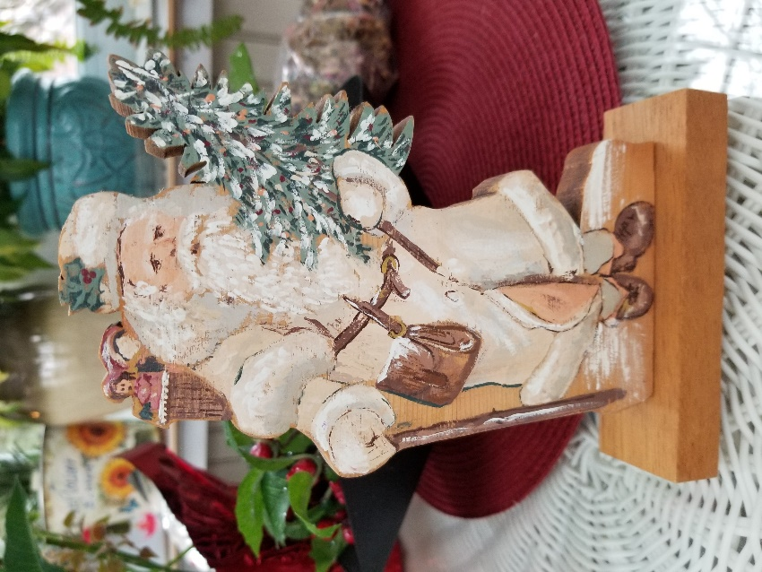

A little more difficult- true of false

1. The name of the land filled with rejects from Santa’ workshop was “The Land that Time Forgot”
2. In Germany and England, they celebrate two days of Christmas.
3. “Twas the Night Before Christmas” was written by Clark Griswold.
4. A “Putz” refers to the villages and landscapes sometimes with miniature trains which people set up under their Christmas trees.

10. George Clooney’s famous aunt, Rosemary starred with Bing Crosby in the epic 1954 “Whie Christmas”

Fill in the blanks- our nemesis

1. In the typical Christmas Creche, who are the figures who visited Jesus? Including animals.

1. How many of Santa’s nine reindeer can you name?
2. What were the three gifts the wisemen brought to Jesus?
3. When we were at Cedar Cliff a Christmas dance, sponsored by the “51Club” which many of us attended. What was it called?
4. One of the most popular American Christmas carols was written and composed by two Austrians. It has been translated many times into many languages and of course into English. What is the name of this beloved carol?

We are still looking for memories of good times (or bad times) ice skating when we were young and nimble. While I remembered skating at both Silver Lake and the Lemoyne Ice Company, my most memorable ice- skating experience happened on the Susquehanna River. During a friendly hockey game, the New Cumberland Police came and escorted us off the ice.

Wishing you all a very Merry Christmas and a happy and healthy New Year. May your stockings be filled to over-flowing with good things.

Brian