Special Education Quarterly

March 23rd, 2016

What’s Inside:
*Transition!!
*Upcoming Events
*Quotes

Transition (Introduction / Examples)
The beginning of each IEP should start with a paragraph that introduces the student. Things to include in this paragraph are the student’s

• Age
• Grade
• Disability (diagnosed disability--- needed by agency)
• Current program
• Anticipated graduation date (and if they are graduating on credits or goals)
• Current number of credits (High school only)
• Related Services (OT/PT/Speech)
• Brief mention of post-secondary goals

Middle School Example:
Ethan is a 14 -year old 8th grade student at New Cumberland Middle School. He receives itinerant learning support services for math and support with organization. He has been identified as a student with a specific learning disability in mathematics problem solving. He is also diagnosed with ADHD. He is anticipated to graduate in 2020. Ethan is interested in a career in the military after graduation.

High School Example:
John is seventeen-year-old junior at Red Land High School where he receives core subjects and testing accommodations in the learning support supplemental classroom. He is mainstreamed for elective courses. John has been identified as a student with the
academic classification of Other Health Impaired – due to his ADHD. John currently has 20 credits towards his graduation requirement of 25 credits. He will graduate in 2015 on credits. Based on previous transition assessments, John has expressed an interest in obtaining further education, possibly at HACC to study criminal justice, and hopes to work in security or related field.

Transition (Key Points)
• The Post-Secondary Education/Training and Employment sections must both be completed with a goal, service(s) and activities. Both sections should be marked YES. There must be a minimum of 1 service and 1 activity in each section. Services may be repeated, but activities may not.

• The Independent Living section must be addressed, whether the student does or does not need an independent living goal based on a current independent living assessment that was given. The date must be included and the results should be reported in the present levels. If a student does not need an independent living goal, do not list any courses of study, service(s) or activities, and mark NO.

• Courses of study should be listed for the current year, and projected for the following school year. A revision must be done at the beginning of the school year to reflect the student's schedule, if different from the projected courses. *Make sure you are using specific course names if there are multiple sections of a course (e.g. Independent Living Skills II).

• Agencies: A statement must be written in the present levels regarding agency involvement. Whether a student has an open case with an agency (list the agency/caseworker), agencies were discussed at the meeting (document what was discussed), or it is too early to determine agency involvement due to the student’s age.

• Location of service(s)/activities: Use the type of classroom the student receives services (e.g. Learning Support Classroom, Life Skills Classroom, etc.) If the activity takes place in the community, you can use Community as the location.

• Person/Agency responsible: Just put WSSD, do not write student, family, or a specific teacher's name. You can list CPAVTS if that school is providing a service or a need in conjunction with WSSD.

• Assessments: All assessments that were given need to be reported in the present levels: name it, date it, and interpret it!

• Measurable Annual Goals (MAGS): Must be written on skill deficit areas, not on curriculum.

*Summarizing Data - At the end of the transition present levels of performance the goal statements from the transition grid should be recapped, and a summary of the previous year(s) transition assessments and the current year's assessment should be summarized, noting if the student's interests have stayed the same or have changed over the years. For example:

-Post-Secondary/Training: Upon graduation from high school John has a goal of attending a 2 or 4-year post-secondary program to study a computer related field.
-Employment: Upon graduation from high school, based on present levels of performance, John has a goal of seeking competitive employment based in his area of stud, a computer related field.
-Independent Living: Upon graduation, based on present levels of performance, including an independent living assessment given on 3/1/16 the IEP team has determined that John will be able to live independently without support.

-Summarizing Data: Based on the transition assessment John completed in 9th grade, and the current assessments he completed during the 2015-2016 school year as a sophomore, John continues to express an interest in a computer related field. John and Mrs. Smith discussed the Computer Networking program at vo-tech, and the process of applying. -Agencies: OVR was discussed at John’s IEP meeting on 1/15/16. An application and informational packet was given to the parents at the meeting. John currently has an open case with York County MH/IDD; his case manager is Sally Green. John and his family is recommended to explore the Pennsylvania Secondary Transition Guide - www.secondarytransition.org. This website offers information on agencies and support, community living, employment, health, self-determination, recreation and leisure, financial supports and services, post secondary education and resources, and schools.

Transition (How to report on an assessment: Name It, Date It, Interpret It! - examples)
Student Planning Questionnaire
John completed the student interview on 1/15/16. When asked what kind of courses he was taking during high school John said general education. Upon graduation, he does not see himself going onto further education or training. He stated that he would like to study/train doing things that are hands on. When asked about his level of motivation to succeed in the academic setting he feels that he has a medium level of motivation. He feels that he has a medium level of control over his decision-making and individual success. His ability to identify what he needs and how to get it he feels is high. Upon graduation, he does want to get a job right away, in the form of part-time employment. Five years after graduation, he is unsure of what he would like to be doing. As far as what courses he needs to take in high school to help attain his employment goals, he is unsure. John explained that he has had some work experience restoring Rick’s campground. A job John dislikes is farming. John participates in baseball and soccer. His favorite hobby is skateboarding. He would like to participate in woodworking in high school. John’s biggest concern for his future is losing a job and not being able to live alone.

Myers Briggs Type Indicator
1/15/16 John completed the Myers Brigg Personality Inventory and based on his responses his personality type is ENTJ (Extrovert-Intuitive-Thinking-Judging). Individuals with this personality preference profile are often: confident leaders who like to be in charge, decisive, ambitious, likes intellectual exchange, ingenious, resourceful in solving complex problems, innovative, analytical, logical, self-determined, independent, and aspires to be the best at whatever he does. Careers that often correspond with the ENTJ personality type include: executive, administrator, education, banker, marketing, manager, science, and criminal justice.

PA Career Guide
1/15/16 After taking the assessment, John’s interest code was: Realistic-Social-Conventional/Investigative. Realistic meaning he is skilled at working with tools, mechanical or electrical drawing, machines or plants and animals. Generally avoids social activities like teaching, healing and informing others. Sees self as practical, mechanical, and realistic. Possible occupations include: welders, packing machine operators, truck drivers, and refuse collectors. Social meaning he is good at teaching, counseling, nursing or giving information. Generally avoids using machines, tools or animals to achieve a goal. Sees self as helpful, friendly and trustworthy. Possible occupations include: childcare workers, secondary school teachers, social workers, personal financial advisors, and registered nurses. Conventional meaning he is good at working with written records and numbers in a systematic, orderly way. Generally avoids ambiguous, unstructured activities. Sees self as orderly, and good at following a set plan. Possible occupations include: bookkeeping and accounting clerks, billing clerks, cost estimators, legal secretaries, computer support specialists, and management analysts. Investigative meaning he is good at understanding and solving science and math problems. Generally avoids leading, selling, or persuading people. Sees self as precise, scientific, and intellectual. Possible occupations include: pharmacies, financial analysts, cardiovascular technologists, systems analysts, and nuclear engineers.

Independent Living Assessment
2/23/15 When asked about auditory perception, John can follow spoken directions and remember what he has heard most of the time. In regards to spoken language John can remember the names of people or things most of the time, and some of the time can tell a story so that people understand and recall the exact word he wants to use. In the area of orientation, John can keep a schedule most of the time, and some of the time loses track of time, is able to judge distance, and is easily distracted from what he is doing. Not very often does he get lost easily or is able judge weights. As for his motor coordination, John can almost always walk/run without difficulty, play sports, keep his balance, use hand tools, and is able to see clearly. Most of the time he can write legibly, and some of the time he can draw pictures. When asked about his personal/social skills, John almost always attends social functions, and most of the time he is able to make and keep friends, other people get along with him, and is able to get all of his work done. Most of the time people are able to understand him, he can understand other people, other people get along with him, and he is able to get all of his work done. Some of the time he makes mistakes and needs help from others. Not very often does he get upset easily. Visually, John most of the time, can remember what he saw, and some of the time he reads the newspaper, has difficulty with math, and has problems when someone shows him how do something. Every so often, he has difficulty using directions in putting something together. When asked questions on living skills, John stated he is able to do the following on his own: shop for his own clothes, eat at a restaurant, cook a snack, and make change for any amount of money without using a calculator. If someone helps him, he is able to: shop for groceries, use public transportation, cook a meal like Thanksgiving, keep a checking account, and budget a weekly paycheck or allowance. He did not seek help in completing this assessment. John does not have his driver’s license at this time.

Self-Determination
2/24/15 John completed the Disabilities Service Worksheet. John stated that he does have a documented disability, ADHD. John stated his learning strength is hands on opportunities. He stated that he has difficulty with the following types of learning: written tests, where explanation is involved and memorizing things. John reported that he began receiving support services in 1st or 2nd grade. He stated that he receives the following support services in high school: learning support classes. When asked how he performed in the following areas, he stated he is above average in: memory, persistence, and motivation. John feels he is average in: attention span, study skills, goal setting, planning, managing feelings, social skills, problem solving, and decision-making. He feels he is below average in time management and staying on task. Academically, John feels he is average in: reading comprehension, reading speed, writing mechanics, writing reports/stories, spelling, math concepts, math calculation, math word problems, test taking, and note taking. When asked about managing feelings, John stated he rarely has a problem with anxiety, but has to work on managing his depression and anger. In order for John to be successful in college he stated that he would need the following accommodations: extended time for tests, note taker for lectures, use of a calculator when appropriate, and extended time to complete assignments. He feels he would need the following support service in college: texts in alternate format, time management assistance, study skill class, reduced course load, career counseling, and help with social skills.

C.I.T.E. Learning Style Inventory
John completed the C.I.T.E. Learning Styles Inventory on 2/24/15. Based on the results of his responses his major learning style was Social Group. As a social group learner, John may have more of a preference to study with at least one other student, and will not get as much done alone. He values others’ opinions and preferences. Group interaction increases his learning and later recognition of facts. Class observation will quickly reveal how important socializing is to him. His minor learning styles were: Social Individual, Kinesthetic-Tactile, and Auditory Language. As a social-individual learner, John gets more work done alone. He thinks best and remembers more when the learning has been done alone. He cares more for his own opinions than the ideas of others. Teachers do not have much difficulty keeping him from over-socializing during class. As a kinesthetic-tactile learner, John learns best by experience, doing and self-involvement. He profits from a combination of stimuli. The manipulation of material, along with accompanying sight and sounds (words and numbers seen and heard) will aid his learning. He may not understand or be able to concentrate or work unless he is totally involved. He seeks to handle, touch and work with what they are learning. As an auditory language learner, John learns from hearing words spoken. He may vocalize or move his lips or throat while reading, particularly when striving to understand new material. He is more capable of understanding and remembering words or facts that could only have been learned from hearing.
*Checklist

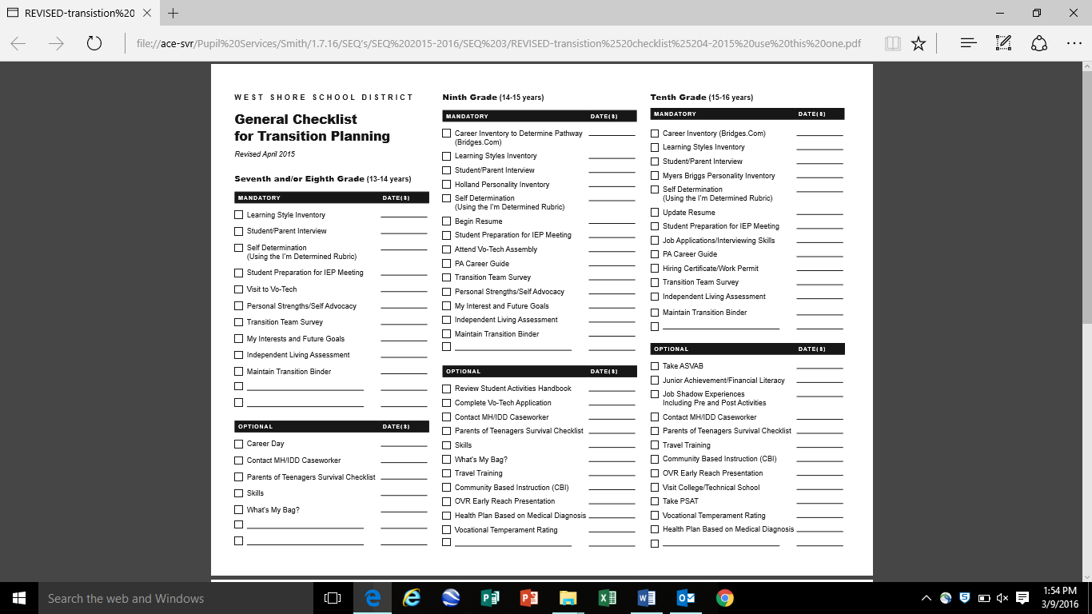

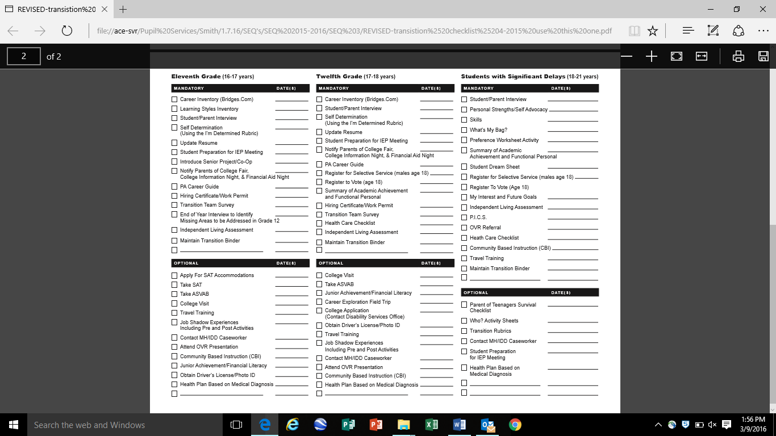

Transition (When to Involve Agencies)
Office of Vocational Rehabilitation (OVR) – When to refer to OVR
The Office of Vocational Rehabilitation (OVR) serves people who have disabilities -physical, mental, emotional - that present a substantial impediment to employment. Services are provided to individuals to prepare for, entering into, engaging in, or retaining employment services.

There is no cost to apply for OVR services. Additionally, there is no charge for diagnostic services, vocational evaluations, counseling or job placement assistance. If a student is eligible for services, the counselor may request documents showing the families income and related expenses (medications, co-pays, etc.). Depending upon income, there may be a contribution to the cost of OVR services. OVR cannot pay for any services that a student received before applying to OVR. Even after a student applies, OVR can pay only for those services approved in advance by your counselor.

OVR is recommending that students be referred during the second semester of their sophomore year. OVR packets that include information and applications can be found in the conference rooms at both high schools. *Please make sure students are being referred to the appropriate county they live in.

Once an application is completed, return it to Jen Hoff. She will get it to the appropriate counselor and schedule an intake meeting. The OVR counselor for Cedar Cliff is Kaitlin Salvati and for Red Land is Caitlin Mento.

Invitation
Make sure all appropriate boxes are checked on the invitation and the student's name is listed on the invitation. If the meeting is an annual IEP, the first box should be checked. If the meeting is a revision, the second box should be checked. If the meeting is a Transition Planning meeting, the third box must be checked. If any agencies are going to be involved in the meeting, the fourth box must be checked and the name(s) of the agencies must be listed. As a best practice, provide a separate invitation to both the parent and the student. ***If paraprofessionals are completing your invitations, please make sure they understand which boxes are to be checked for those meetings.

Career / transition Planning Website
http://www.careeronestop.org/

On this website users can do the following:

Explore Careers:
-Offers an interest assessment
-Offers a Work Values lesson. Students can take an assessment to determine what their own core work values are. Great discussion with students.
-Offers information on 900 vocations. Students can read about them, compare them, find out which ones are "hot" careers. They can also research general industries.

Find Training:
- Defines training options that best fits students’ needs.
- High school equivalency
- Adult Basic Education
- Short-term training
- College
- Certifications
- Apprenticeships
- Internships
- Professional development
- Do you need a license?

Job Search:
-Make your job search efforts pay off with research and planning.
- Create a job search plan
- Research employers
- Research salaries
- Online job search
- What's in demand?
- Inquiry letters
- Inquiry letter sample
- Networking information
- Find a job

Search for a job right on the site by entering a job and location in the boxes.
Find your state job bank to post your resume.
What are job banks?
Employment agencies
Military options
Job fairs

-Resumes and Applications
- Resumes
- Cover letters
- Job applications
- Online applications
- Portfolios
- Work samples
- References
- Interviewing and Negations

Tool Kit
-A plethora of other resources for you and your students

Short Career Videos
To just access the videos of most, if not all, of the careers (1:00-2:00 minutes in length), use this link below, or click on VIDEOS on the main website page. (It's in the middle of the page on the left)

http://www.careeronestop.org/Videos/CareerandClusterVideos/career-and-cluster-videos.aspx

Transition (Resources)
Helpful Transition Websites

• Must include in the transition present levels of performance in the agency statement:
Student/family is recommended to explore the Pennsylvania Secondary
Transition Guide - www.secondarytransition.org. This website offers information on
agencies and support, community living, employment, health, self-determination,
recreation and leisure, financial supports and services, post- secondary education and
resources, and schools.

• PA Department of Special Education - www.education.pa.gov/K-12/SpecialEducation

• Secondary Transition Guide - www.secondarytransition.org

• Transition Checklist - www.health.state.pa.us/transitionchecklist

• Department of Labor and Industry - www.dli.pa.go

• PA Department of Labor and Industry Career Guide - http://www.portal.state.pa.us/portal/server.pt/community/publications/19877

• PaTTAN - www.pattan.k12.pa.us

• Transition Assessments and Activities - http://sped.sbcsc.k12.in.us/ppm/transitionplanning/transitionassessments.html

• Council for Exceptional Children - www.cec.sped.org

• Center for Independent Living of Central Pennsylvania - www.cilcp.org

• Office of Vocational Rehabilitation - http://www.dli.state.pa.us/portal/server.pt/community/vocational_rehabilitation/10356

• RESCARE - www.rescare.com

• AHEDD - http://www.ahedd.org/

• GOODWILL-Keystone Area - www.yourgoodwill.org

• Keystone Human Services - http://www.keystonehumanservices.org/

• Living Unlimited - http://www.living-unlimitedinc.com/

• ASERT-PA Autism Resource
http://www.paautism.org/

• My Next Move-O*Net - http://www.mynextmove.org/

• Job Gateway - www.jobgateway.pa.gov

• PA Career Zone - www.pacareerzone.org

• United Cerebral Palsy of Central PA-UCP - http://www.ucpcentralpa.org/

• The ARC of Pennsylvania - http://www.thearcpa.org/

• The ARC of Cumberland and Perry Counties
-CPARC - www.cparc.org

• Works For Me - http://worksforme-pa.org/

Upcoming Events
*April 29th, Early Dismissal / Staff Development

*May 27th, Early Dismissal / Staff Development

Quotes
If kids come to us [educators, teachers] from strong, healthy functioning families, it makes our job easier. If they do not come to us from strong, healthy, functioning families, it makes our job more important. – Barbara Colorose

If a child can't learn the way we teach, maybe we should teach the way they learn. – Ignacio Estrada

By:
Angela Caufman, Jen Hoff, Kristen Peters, Linda O’Connor, April Smith, Pam Ringhoffer

