First, log into the Parent Portal at https://psweb.wssd.k12.pa.us/public/

Click on

After reading through the information, click on

Click on

The following screen will appear:

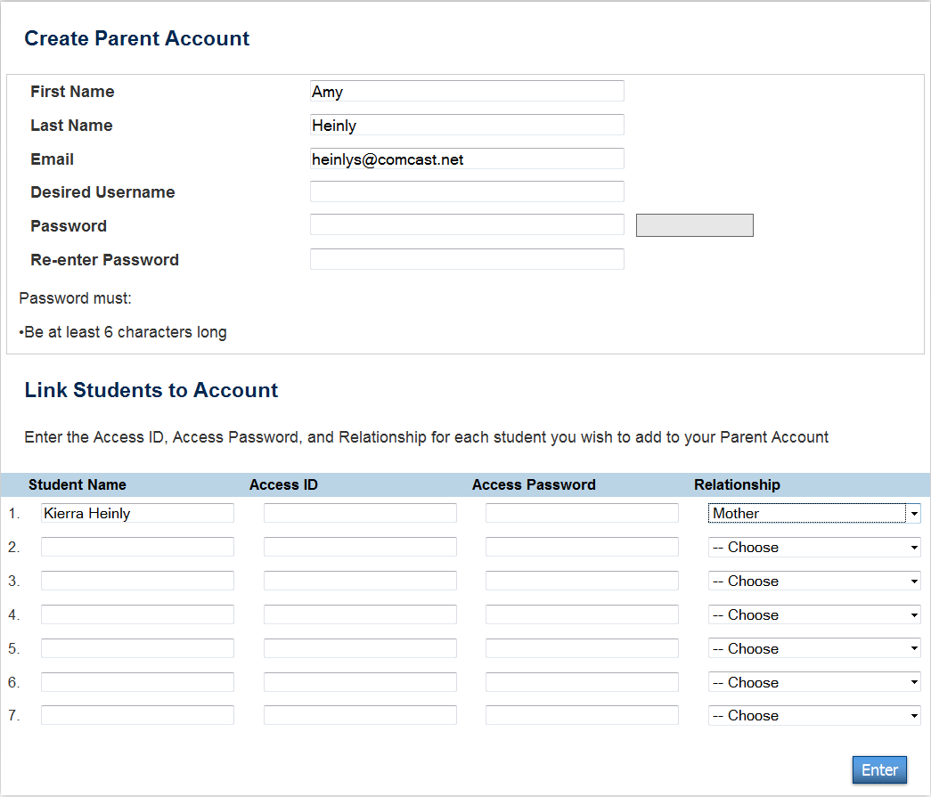
Enter the Access ID from your letter here – this should be a 5 letter word; password is case sensitive

Enter the Access Password from your letter here – this should be a 4 digit number
Retype your desired Password here
Type your desired Password here
Type your desired Username here
Enter the Access ID from your letter here – this should be a 5 letter word; password is case sensitive

Click on

Now you should be able to navigate through Parent Portal.
Reenter your desired password here

