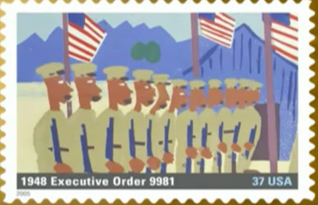
Executive Order 9981
Start: 00:00
End: 4:47

- September 1940, what law/act did Congress pass?

- What did it state in regards to blacks being represented in the military?

- How did the various branches of the military accept blacks wanting to fight for their country?

- What was Vernon Baker’s attitude towards serving in the military and the country?

- What did Executive Order 9981 do and who issued the order?

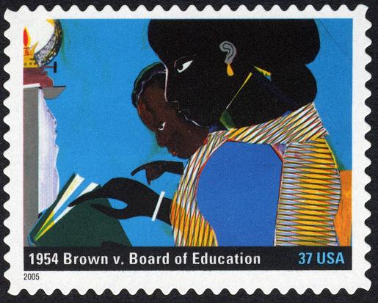
Brown v. Board of Education
Start: 4:59
End: 7:50

- What was the opinion of the U.S. Supreme Court when it came to educational facilities for black and white children?

- How fast does Marshall say the Court’s decision will give counties and states to desegregate their schools?
- What does Thurgood Marshall say the decision will provide to “…all of the children of our nation…” ?
- What is the opinion of the black students on the court’s decision and desegregation?
- What is the opinion of the white student on the court’s decision and desegregation?

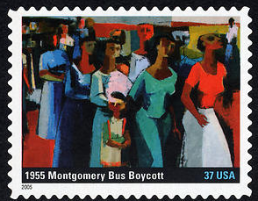
Montgomery Bus Boycott
Start: 7:57 Starts on Part One, ends on part two
End: 11:34

- What event precipitated the Montgomery Bus boycott and when it end?
- What reason is given for not integrating the bus lines of Montgomery?
- Approximately how many of the city’s black population participated in the boycott?
- What does Martin Luther King, Jr. describe as the “honorable” thing to do?

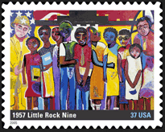
Little Rock Nine
Start: 11:41
End: 00:43 on Part two

- What does the narrator state is easier to organize than “understanding”?
- What state does this event take place in?
- What U.S. President sent troops to the city to “carry out the law” and when did this happen?
- What do you think the narrator means when he states “…that when the doors closed behind us, it was both an end and a beginning.”?

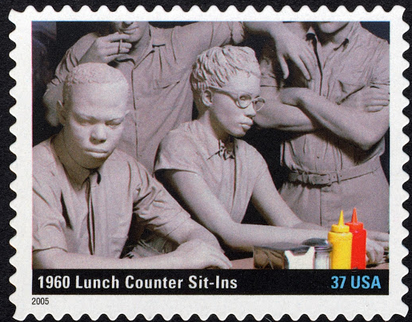
The Lunch Counter Sit-ins
Start: 00:52
Ends: 3:35

- What form of civil disobedience began in Greensboro, NC in 1960?
- What southern state was the only state that protests did not occur in?
- How does John Lewis describe his participation in the protests?
- What was the true test for the participants of the sit-ins?

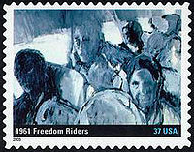
Freedom Rides
Start: 3:43
End: 6:18

- What was the purpose of the freedom riders traveling through the South?
- What would the freedom riders do as their busses stopped at bus stops?
- How would the local population (both the police and civilians) react to the actions of the Freedom Riders?

