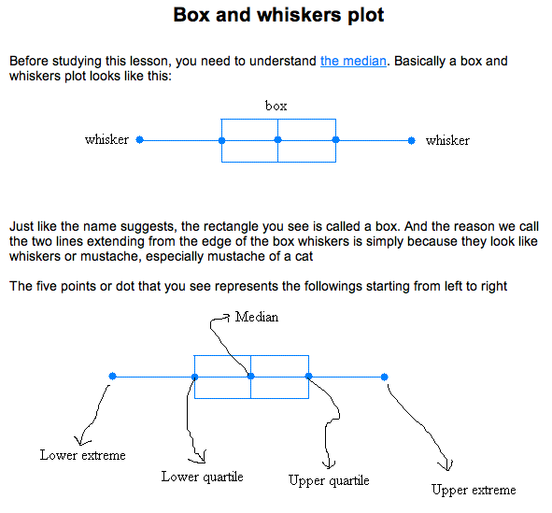
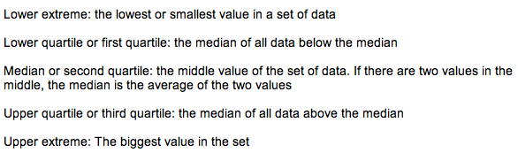
Construct a box and whiskers plot for the data set: {5, 2, 16, 9, 13, 7, 10}

First, you have to put the data set in order from greatest to least or from least to greatest

From least to greatest we get : 2 5 7 9 10 13 16
2 5 7 9 10 13 16
Q3
Median
Q2
Q1

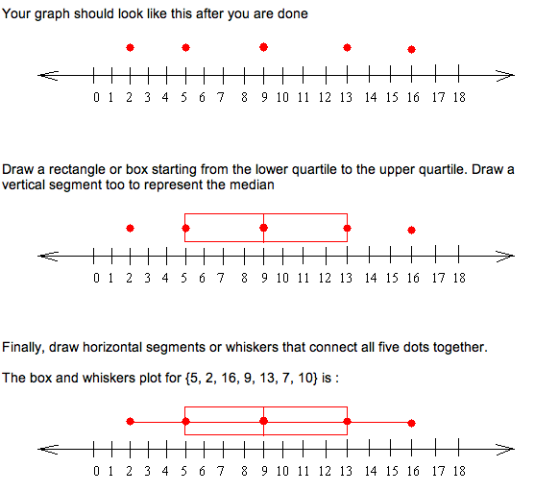
Lower Q1 Median Q3 Upper
Value Q2 Value

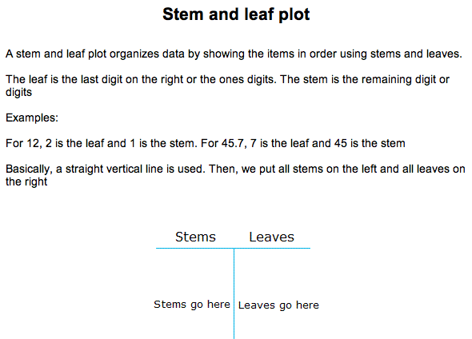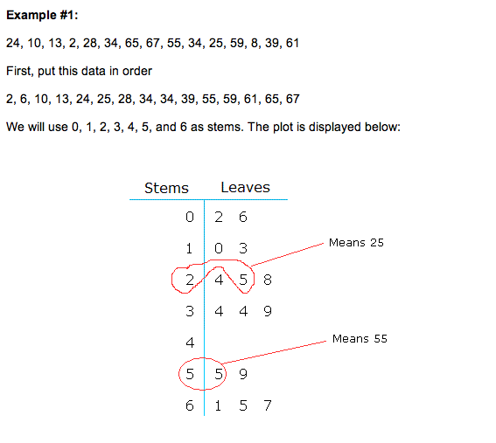

Linear Equations

